Source code: embedded\IMUArduinoTes.ino
Test 1: Flat on Table
AccX | AccY | AccZ | GyrX| GyrY | GyrZ \ Temp
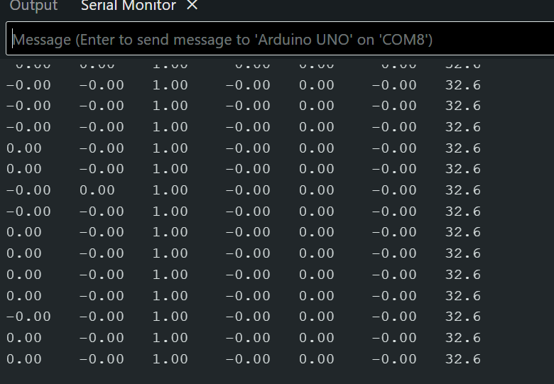
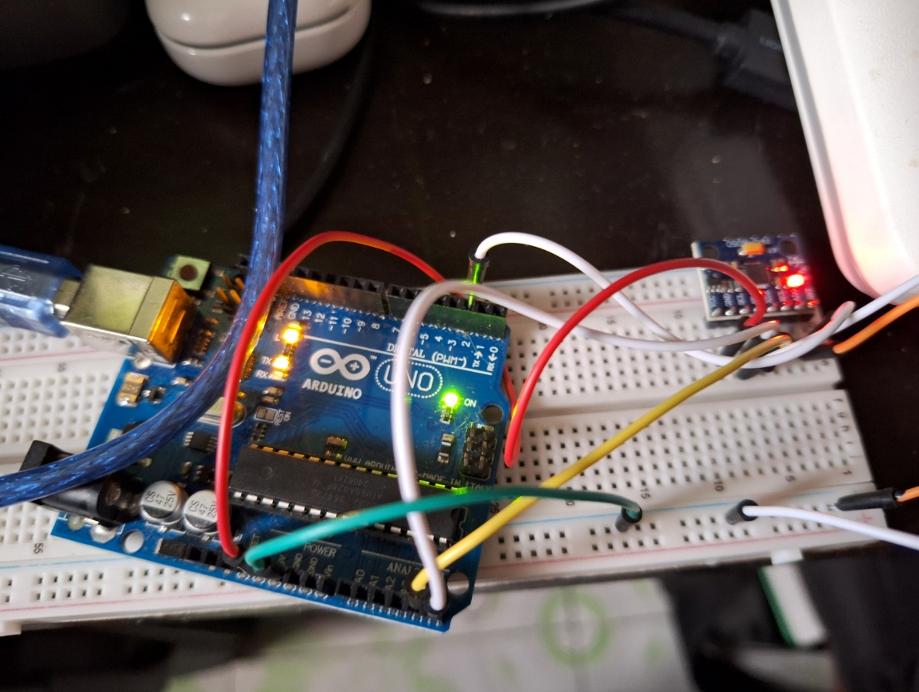

Test 2: Upside down
AccX | AccY | AccZ | GyrX| GyrY | GyrZ \ Temp
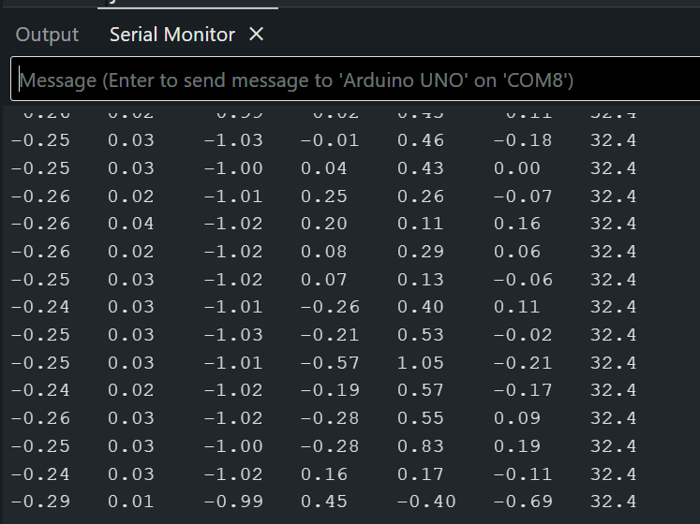
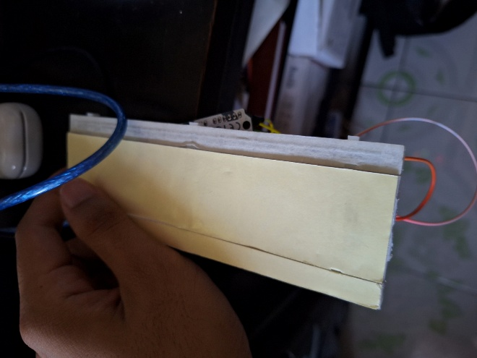
Note: Not completely flat due to the wires

Test 3: Tilt forward
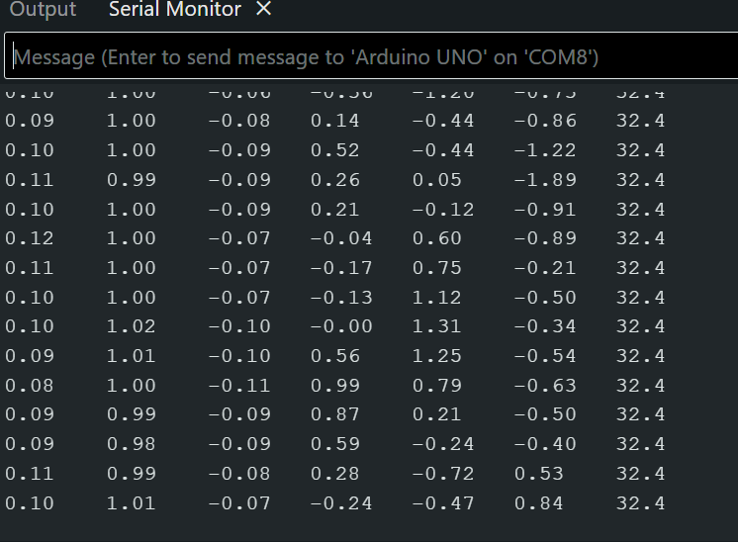
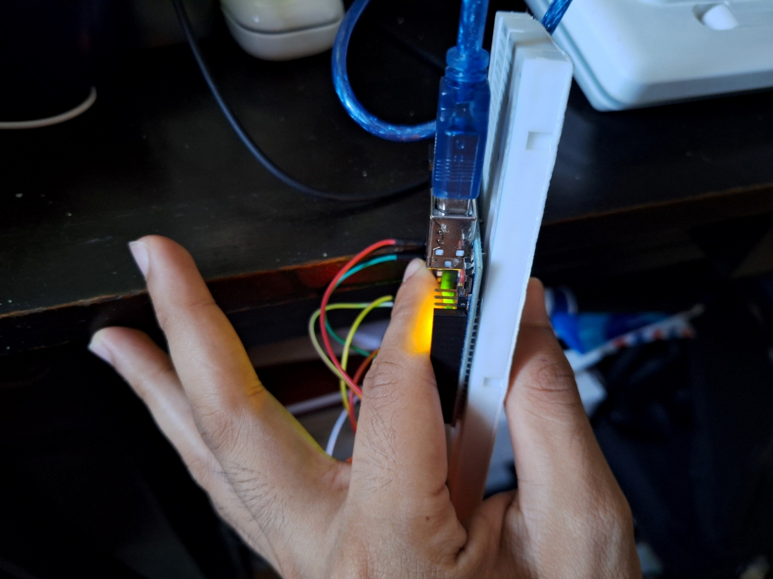
Test 4: Tilt backward
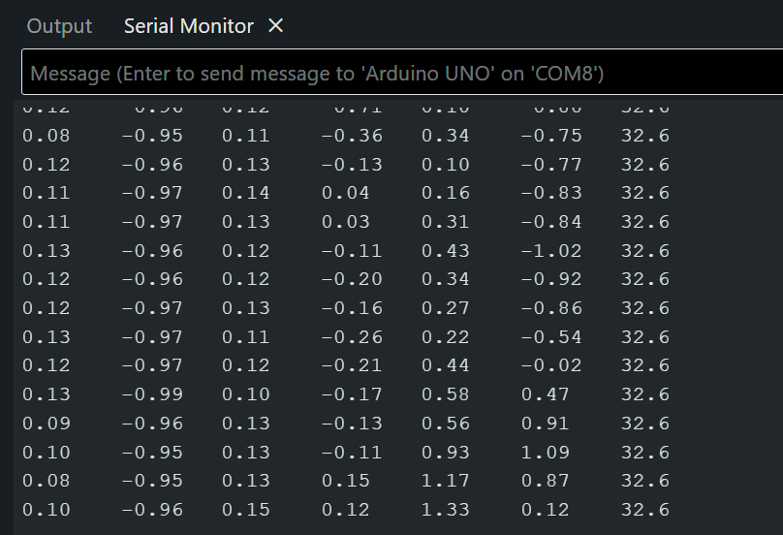
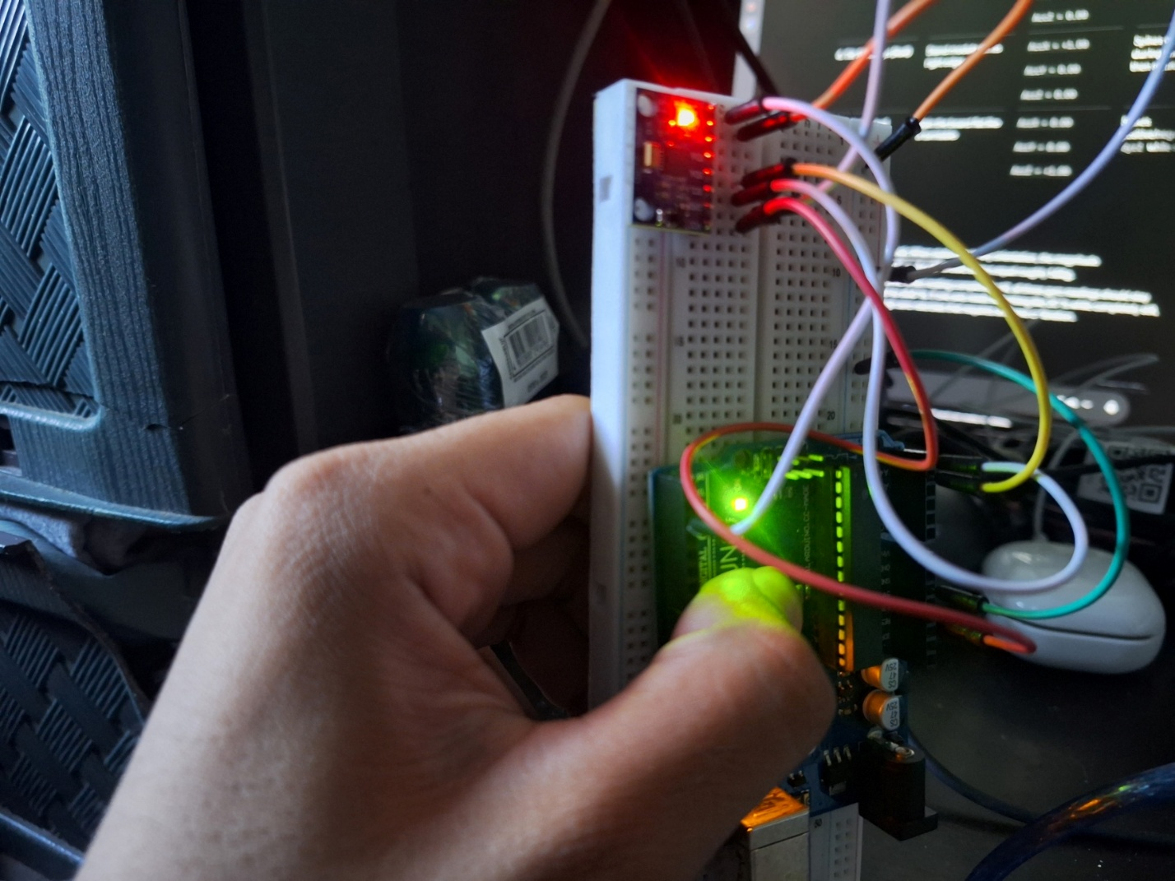

Test 5: Tilt sideways (right)
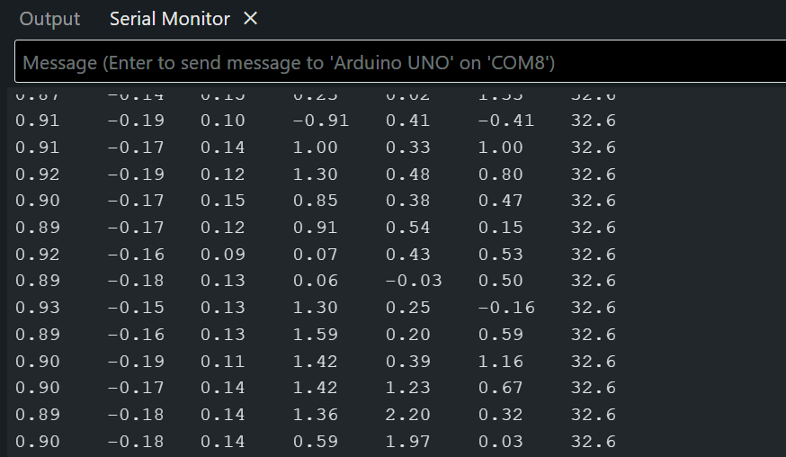
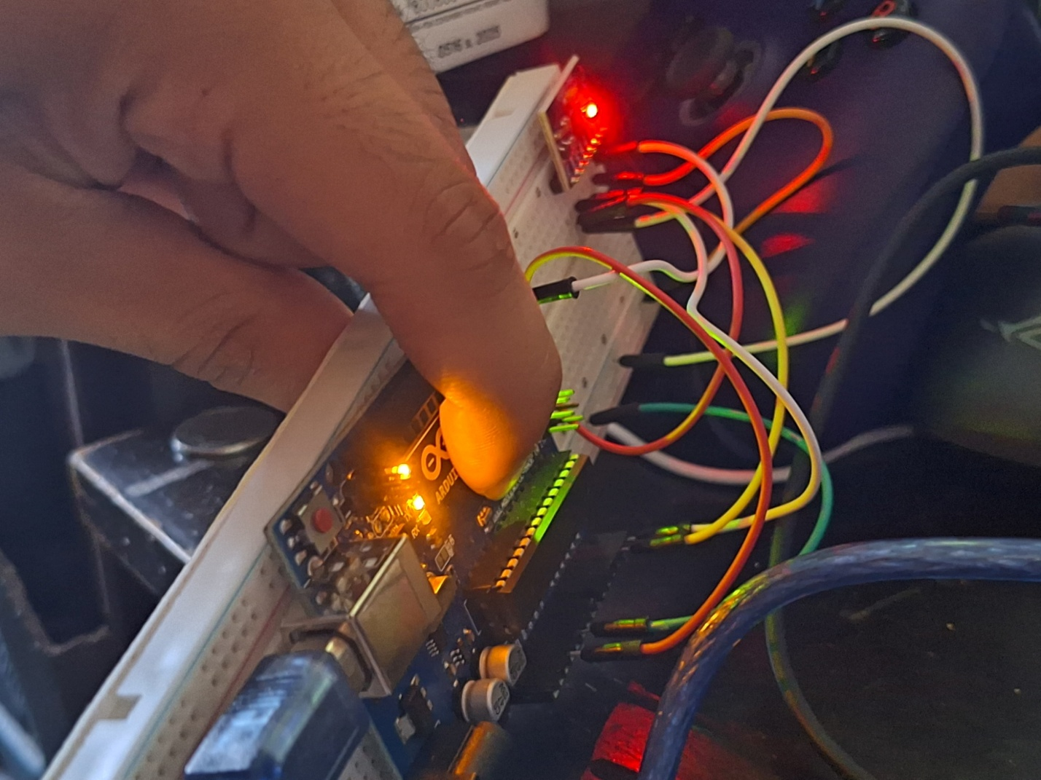

Test 6: Tilt sideways (left)

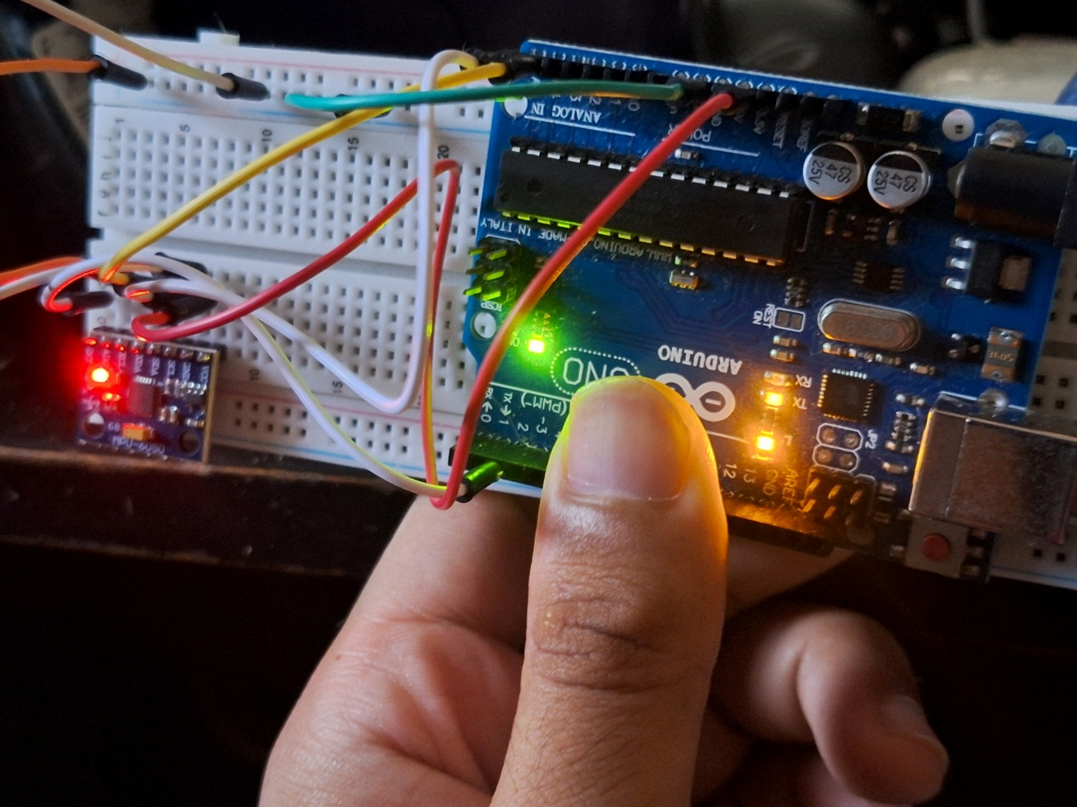

Test 7: moving sensor
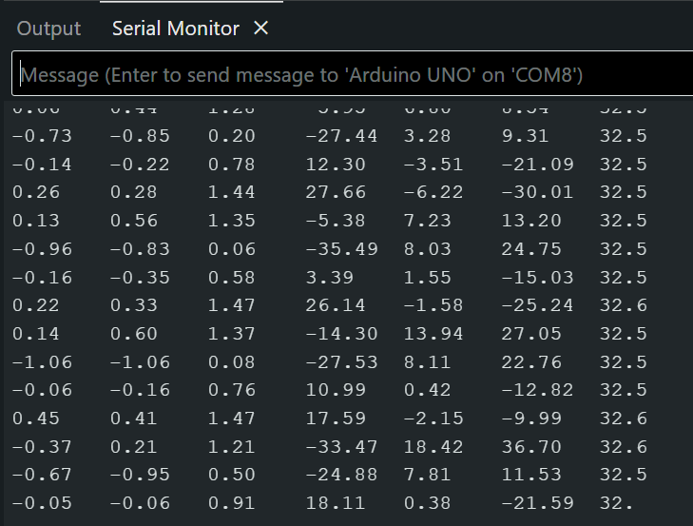
Results:
Clockwise movement towards x, y, or z axis = negative values
Counter clockwise movements towards x, y, or z axis = positive values

